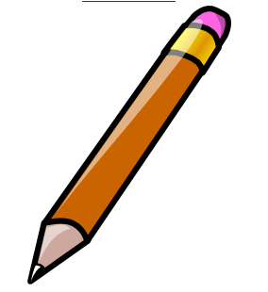

Pencil + Ruler |  | 2 Pencils + 2 Rulers + 2 Pens
Pen + Pencil |  | 3 Rulers + 2 Pencils
3 Rulers |  | 3 Rulers + 3 Pencils
Pencil + Ruler + Pen |  | Pencil + 2 Rulers + 3 Pens
5 Pencils |  | 10 Pencils
Pen + Pencil + Ruler |  | 20 Pencils
10 Pens |  | 6 Pens + 7 Pencils

Name………………………………………………… Time…………………………………………

Pencil + Ruler |  | 2 Pencils + 2 Rulers + 2 Pens
Pen + Pencil |  | 3 Rulers + 2 Pencils
3 Rulers |  | 3 Rulers + 3 Pencils
Pencil + Ruler + Pen |  | Pencil + 2 Rulers + 3 Pens
5 Pencils |  | 10 Pencils
Pen + Pencil + Ruler |  | 20 Pencils
10 Pens |  | 6 Pens + 7 Pencils

Name………………………………………………… Time…………………………………………

